Inspire Explore is a flagship initiative by EIT Food, designed to ignite entrepreneurial thinking in the next generation of change-makers within the food system.
This free, fully online, self-paced course is open to anyone interested in creating solutions for a more sustainable, equitable, and healthy food future — regardless of prior experience.
Beyond learning, IE also empowers participants to compete — through a structured pan-European innovation competition that rewards the most promising, purpose-driven ideas.
At its core, Inspire. Explore. is about bridging education and innovation — taking individuals with potential, giving them tools and mentorship, and helping them develop early-stage ideas into impactful solutions.
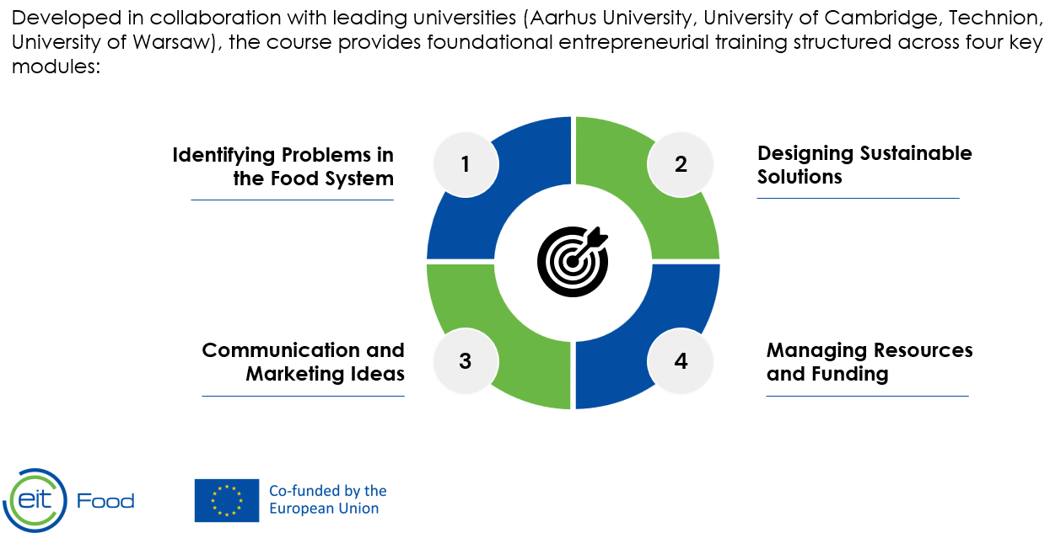
Take it further:
After completing Inspire: Explore, you can enter Inspire: Explore Compete, where you’ll pitch your ideas to a jury for a chance to win cash prizes in one of three challenge categories!
How to join:
Click here to register today.
Questions? Contact Agnieszka Talik at core.inspire@eitfood.eu
Don't miss this opportunity to grow your skills and turn your ideas into impact!

